AI Tool Adoption Trend Analysis Report

Abstract
Artificial Intelligence (AI) adoption has significantly increased across organizations to improve productivity, automate processes, and support decision-making. This study investigates AI tool adoption trends using statistical and analytical techniques. The analysis explores the influence of industry, company size, user satisfaction, and investment on AI adoption. Results indicate that ChatGPT is the most widely adopted AI tool, larger organizations adopt AI more aggressively, and company size significantly impacts AI adoption behavior.

1. Introduction
Artificial Intelligence technologies are transforming industries by enabling automation, enhancing productivity, and improving customer experiences. Organizations increasingly rely on AI tools such as ChatGPT, GitHub Copilot, Gemini, Claude, and Power BI AI to gain competitive advantages.
This project aims to analyze AI adoption patterns and identify factors affecting organizational AI implementation through statistical analysis and business intelligence techniques.

2. Problem Statement
Organizations face challenges in understanding:
- Which AI tools are being adopted most rapidly?
- Which industries lead AI adoption?
- Does company size influence AI adoption?
- Does AI investment result in cost savings?
- What business recommendations can improve AI implementation?
This study addresses these questions using data-driven approaches.

3. Objectives
The objectives of this study are:
- To analyze AI adoption trends across industries.
- To identify the most frequently used AI tools.
- To investigate relationships between organizational characteristics and AI usage.
- To perform hypothesis testing on company size and AI adoption.
- To provide business recommendations for effective AI implementation.

4. Dataset Description
The dataset consists of 500 organizations and 12 variables.

Variables Included
- Organization_ID
- Industry
- Company_Size
- Employee_Count
- AI_Tool
- Adoption_Year
- Monthly_AI_Users
- Productivity_Gain
- Satisfaction_Score
- AI_Investment
- Cost_Savings
- Adoption_Level

5. Data Cleaning and Preparation
The following preprocessing steps were performed:
- Missing value analysis
- Duplicate record identification
- Data type verification
- Descriptive statistical analysis

Findings
- Total Records: 500
- Missing Values: 0
- Duplicate Records: 0
The dataset was clean and suitable for further analysis.

6. Descriptive Statistical Analysis

Productivity Gain Statistics
Measure | Value
Mean | 22.47%
Median | 22.70%
Standard Deviation | 7.30

Quartiles
Quartile | Value
Q1 (25%) | 16.20
Q2 (50%) | 22.70
Q3 (75%) | 28.73

Percentiles
Percentile | Value
10th | 12.19
25th | 16.20
50th | 22.70
75th | 28.73
90th | 32.30

Interpretation
Organizations achieved an average productivity improvement of 22.47% through AI adoption, indicating substantial operational benefits.

7. AI Tool Adoption Analysis

Most Commonly Used AI Tools
AI Tool | Organizations
ChatGPT | 190
GitHub Copilot | 110
Gemini | 60
Claude | 53
Midjourney | 44
Power BI AI | 43

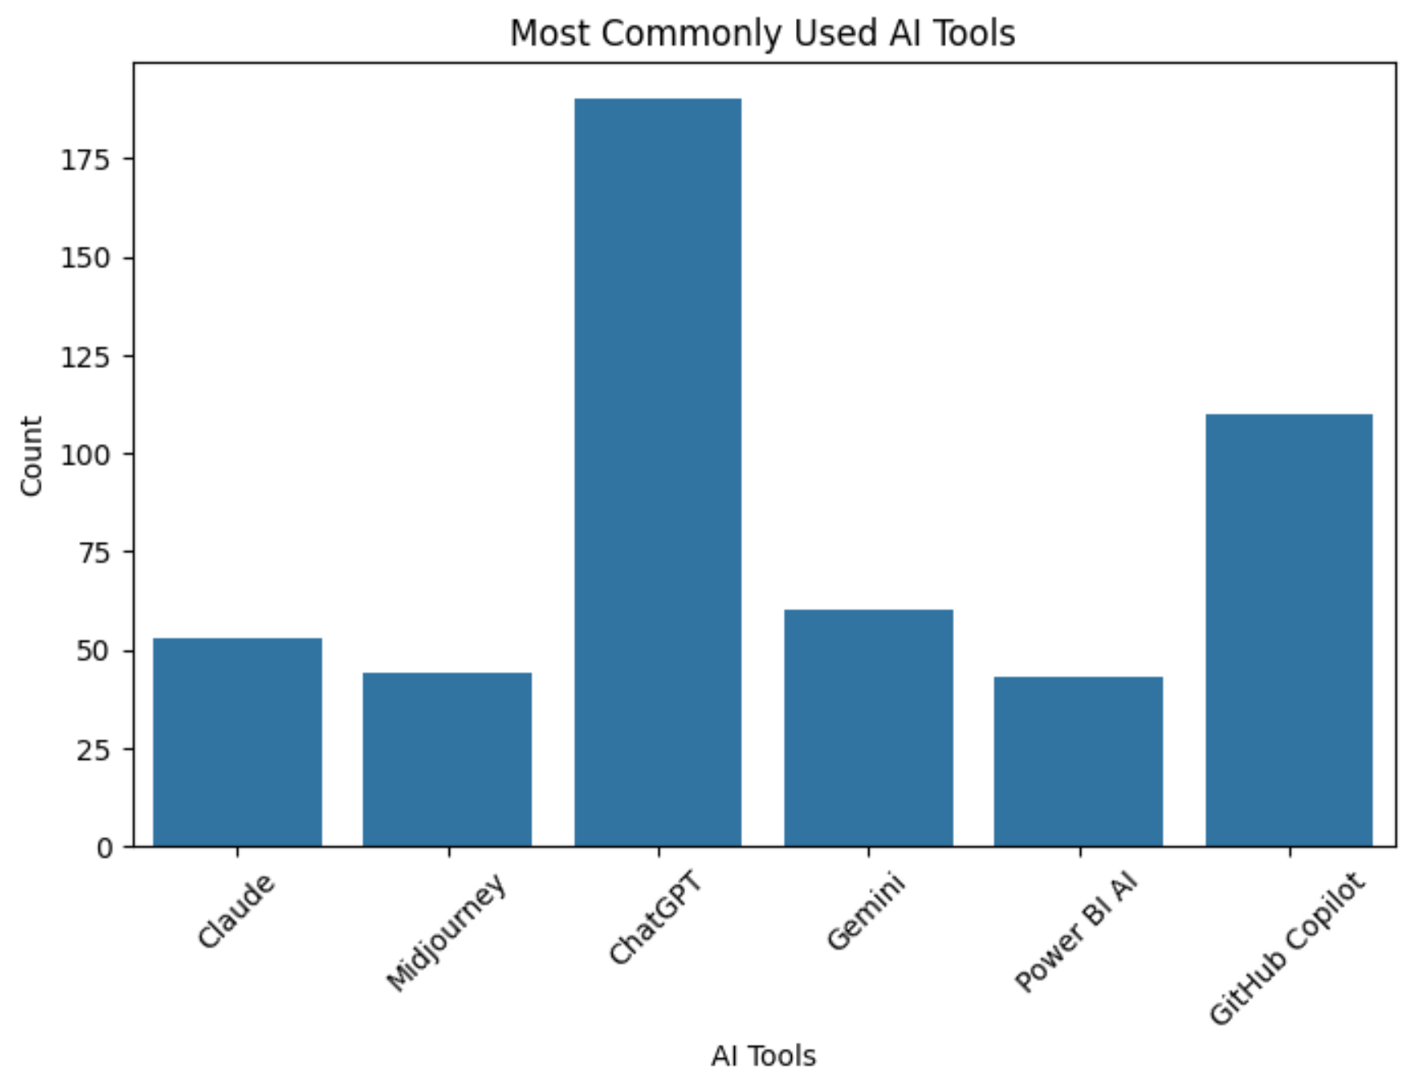

Interpretation
ChatGPT emerged as the most widely adopted AI tool, accounting for 38% of all organizations studied. This indicates strong market acceptance and broad applicability across industries.

8. Industry-wise Adoption Analysis
Industry | Organizations
IT | 124
Finance | 89
Manufacturing | 84
Healthcare | 82
Retail | 80
Education | 41

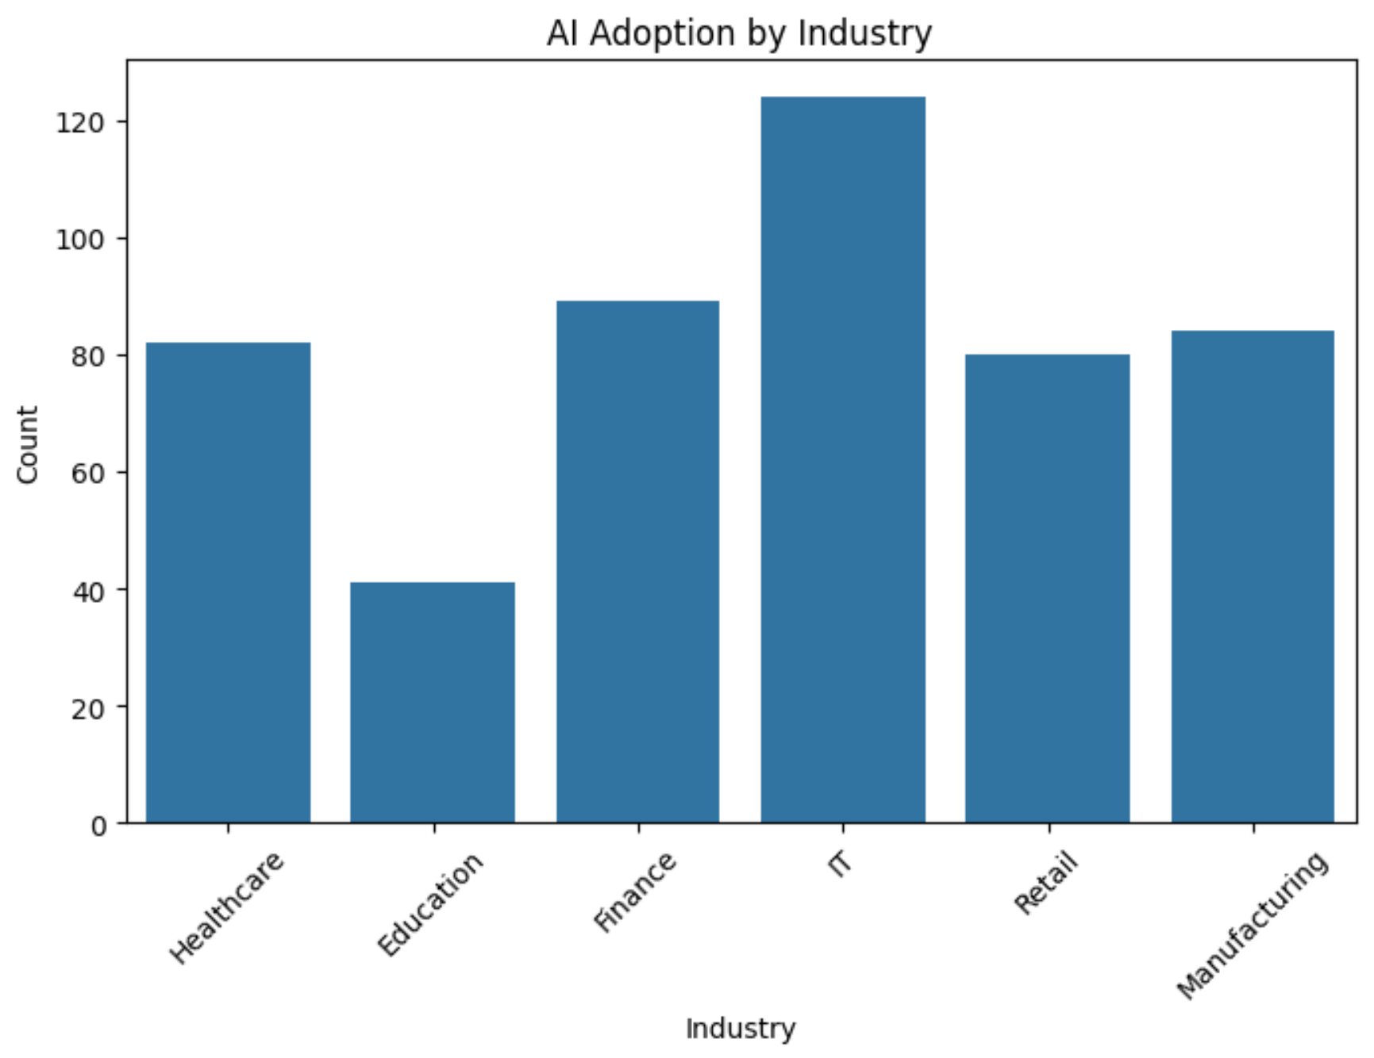

Average Monthly AI Users by Industry
Industry | Average Users
Education | 321
Healthcare | 255
Retail | 233
Finance | 222
Manufacturing | 221
IT | 207

Interpretation
Educational institutions demonstrated the highest AI engagement levels, while the IT sector exhibited the largest number of organizations adopting AI technologies.

9. Company Size Distribution
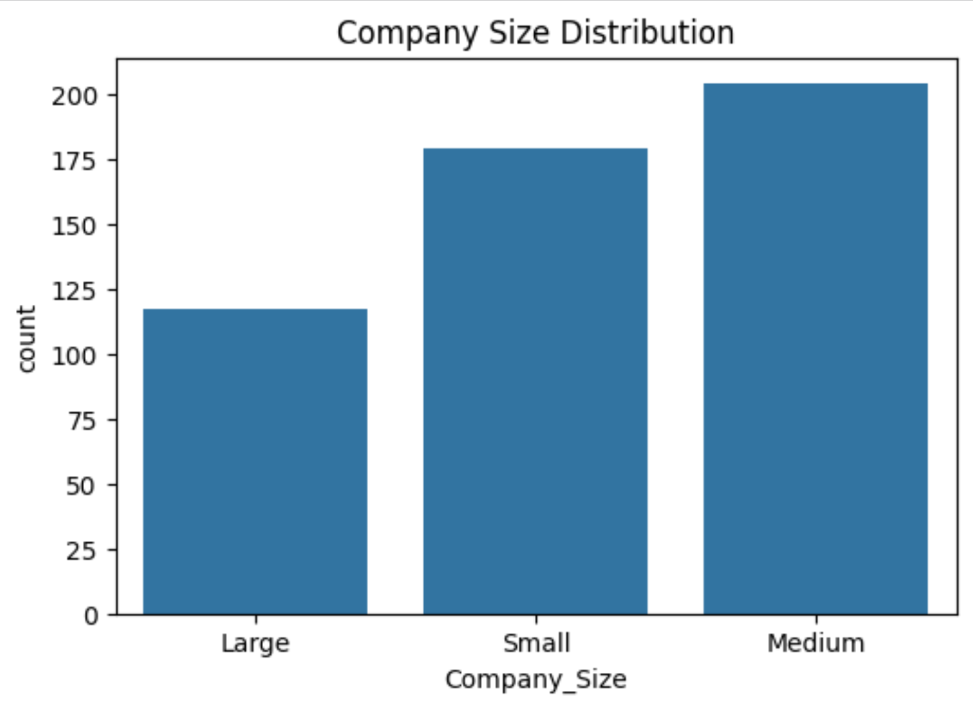
Company Size | Count
Medium | 204
Small | 179
Large | 117

Interpretation
Medium-sized organizations represented the largest proportion of AI adopters within the dataset.

10. User Satisfaction Analysis
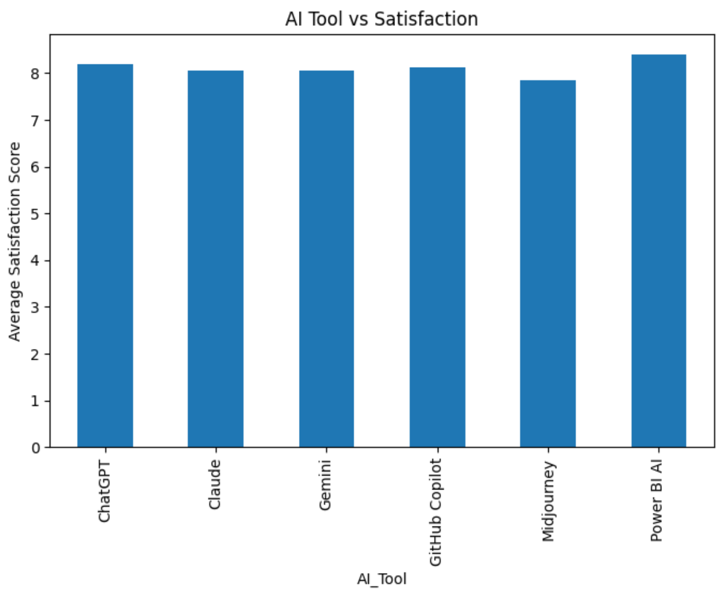
Average Satisfaction Scores by AI Tool:
AI Tool | Satisfaction Score
Power BI AI | 8.41
ChatGPT | 8.19
GitHub Copilot | 8.13
Claude | 8.07
Gemini | 8.06
Midjourney | 7.85

Interpretation
Power BI AI received the highest user satisfaction ratings, suggesting strong effectiveness in analytics applications.

11. Adoption Growth Analysis
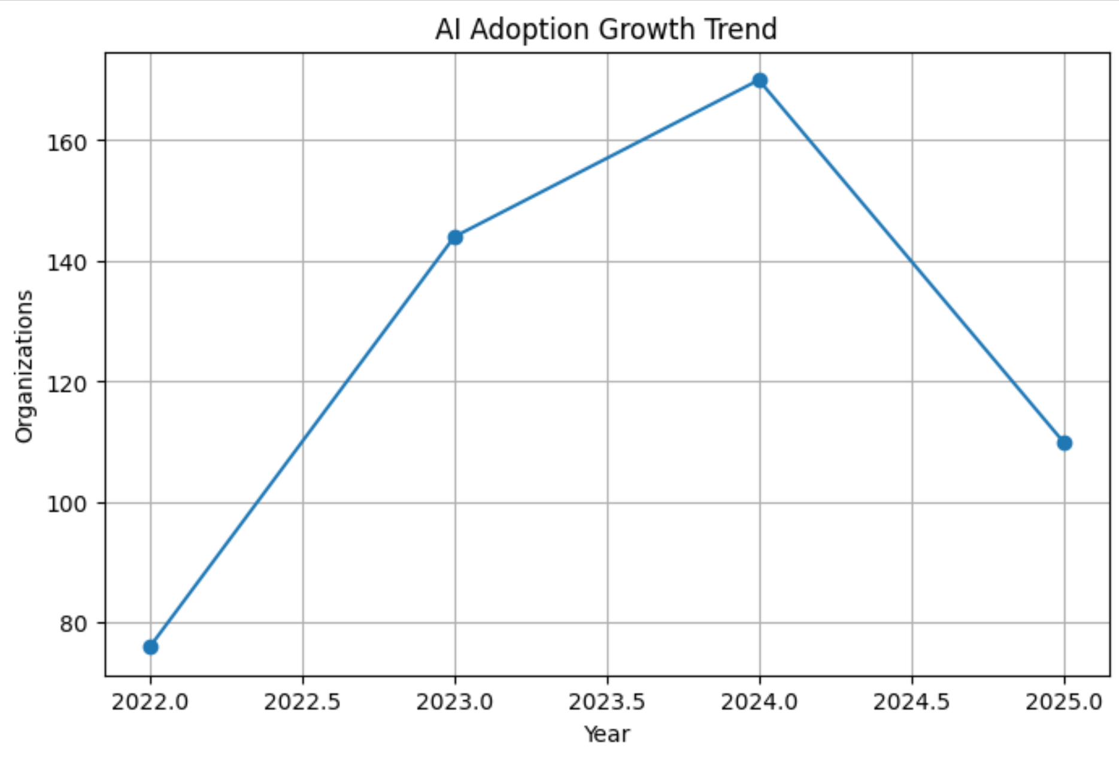
Number of Organizations by Adoption Year:
Year | Organizations
2022 | 76
2023 | 144
2024 | 170
2025 | 110

Interpretation
AI adoption experienced substantial growth between 2022 and 2024, indicating accelerated acceptance of AI technologies across organizations.

12. Correlation Analysis
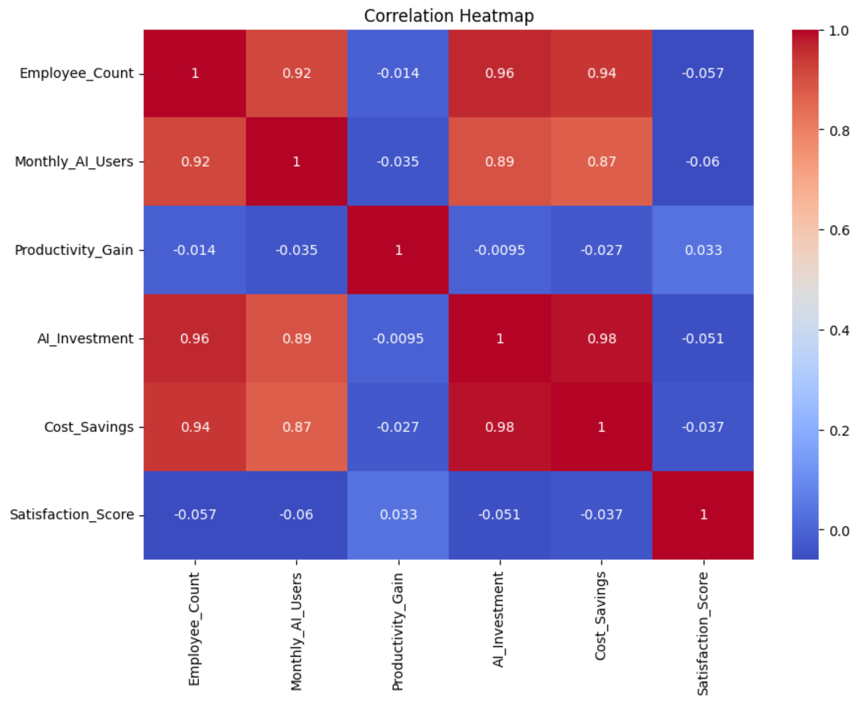

Correlation Results

Employee Count vs Monthly AI Users
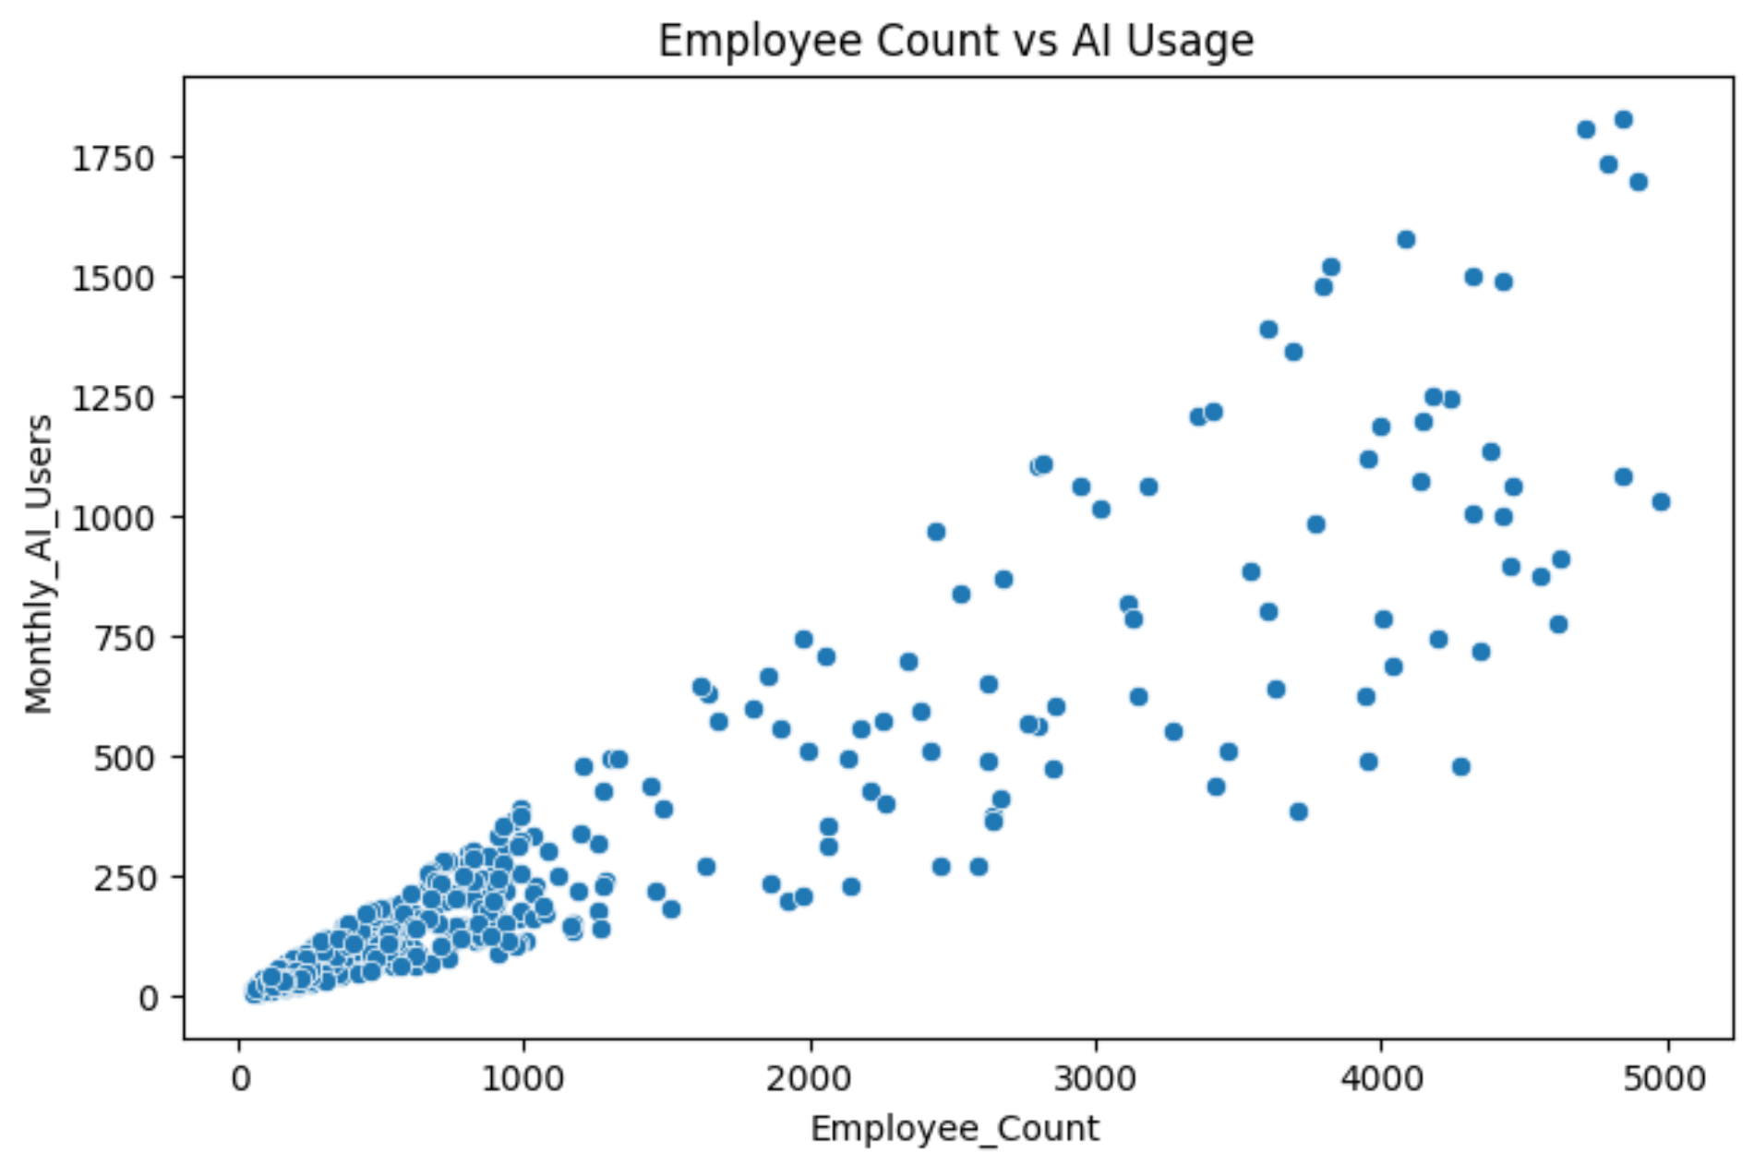
Correlation Coefficient:
r = 0.916
Interpretation:
A very strong positive relationship exists between organization size and AI usage.

AI Investment vs Cost Savings
Correlation Coefficient:
r = 0.984
Interpretation:
Organizations investing more in AI experience significantly greater cost savings.

Monthly AI Users vs Productivity Gain
Correlation Coefficient:
r = -0.035
Interpretation:
Minimal relationship exists between the number of AI users and productivity improvements.

13. Hypothesis Testing

Research Question
Does company size significantly impact AI adoption?

Null Hypothesis (H₀)
Company size has no significant impact on AI adoption.

Alternative Hypothesis (H₁)
Company size significantly impacts AI adoption.

ANOVA Test Results
Statistic | Value
F-Statistic | 368.50
P-Value | 7.12 × 10⁻⁹⁹

Decision
Since the p-value is significantly less than 0.05, the null hypothesis is rejected.

Conclusion
Company size significantly influences AI adoption levels.
Large organizations adopt AI at substantially higher rates than smaller organizations.

14. Organization Segmentation
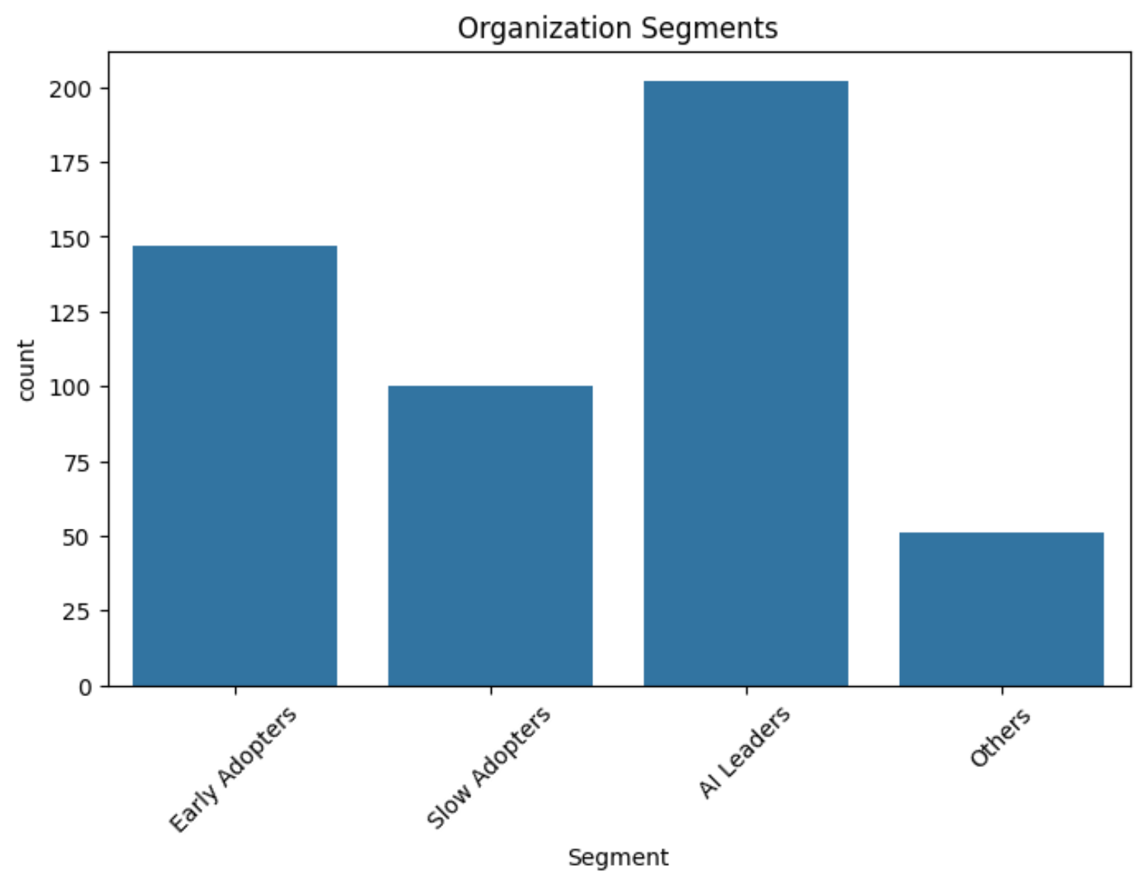
Organizations were segmented into adoption categories.
Segment | Count
AI Leaders | 202
Early Adopters | 147
Slow Adopters | 100
Others | 51

Interpretation
AI Leaders represented the largest group, indicating widespread maturity in AI implementation.

15. Business Insights

1. Which factors affect AI adoption most?
Answer:
- Company size
- AI investment
- User satisfaction

2. Which AI tools increase engagement?
Answer:
- ChatGPT
- Power BI AI
- GitHub Copilot

3. Does investment improve productivity?
Answer:
Yes. Organizations investing more in AI achieved greater savings and adoption.

4. Which organizations are lagging behind?
Answer:
- Small organizations
- Slow adopters

5. Product Recommendations
Answer:
- Begin with pilot projects.
- Provide employee training.
- Focus on high-ROI AI tools.

16. Recommendations
Based on the findings, the following recommendations are proposed:
- Organizations should prioritize AI tools with high satisfaction scores.
- Small organizations should begin with pilot AI projects before large-scale deployment.
- Companies should increase AI investments strategically to maximize cost savings.
- Employee training programs should be implemented to improve AI adoption effectiveness.
- Organizations should continuously monitor AI performance metrics to optimize returns.

17. Future Scope
Future enhancements to this study may include:
- Predictive modeling for AI adoption forecasting.
- Machine learning models for identifying adoption drivers.
- Development of interactive Power BI dashboards.
- Real-time AI usage monitoring systems.

18. Conclusion
This study successfully analyzed AI adoption patterns across organizations using statistical and analytical techniques. The results demonstrate that AI adoption is influenced by organizational size, investment levels, and user experiences. ChatGPT emerged as the most widely adopted AI tool, while Power BI AI achieved the highest user satisfaction. The findings provide valuable insights that can assist organizations in making informed AI investment decisions and developing effective digital transformation strategies.
Overall, AI continues to reshape business operations, and data-driven approaches such as this study are essential for guiding successful technology adoption.

